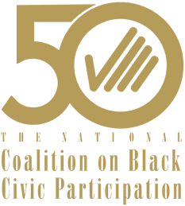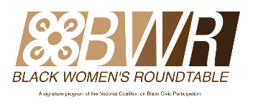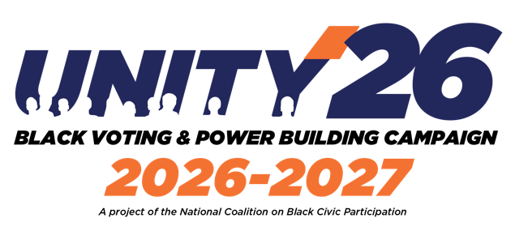

FOR IMMEDIATE RELEASE
October 15, 2026

MEDIA CONTACTS:
Tyrice Johnson
newmedia@ncbcp.org | (205) 643-4755
Lon Walls
lwalls@wallscomm.com | (301) 996-1669
Rachel Noerdlinger
rnoerdlinger@actumllc.com (347) 821-9678

NATIONAL COALITION ON BLACK CIVIC PARTICIPATION & BLACK WOMEN’S ROUNDTABLE KICKED OFF A NINE-STATE ‘POWER OF THE SISTER VOTE GOTV & DEMOCRACY DEFENSE NATIONAL TOUR’ IN GEORGIA

Joined by 40 Black Women-Led National and State-Based Organizations and Allies, the GOTV & Democracy Defense 21-Day Tour Launched on Georgia’s First Day of Early Voting to Mobilize Black Voters and Monitor the Polls

ATLANTA, GA (October 15, 2026) — The National Coalition on Black Civic Participation (NCBCP) and Black Women’s Roundtable (BWR), officially kicked off their Unity ’26 “Power of the Sister Vote” GOTV & Democracy Defense National 21-Day Tour in Atlanta on the first day of early voting in Georgia on Tuesday, October 13th----in partnership with the Georgia Coalition for the People’s Agenda, Georgia STAND-UP, GA BWR, HBCU Green Fund, Black Voters Matter, Delta Sigma Theta Sorority, Incorporated, D4 Women in Action, RISE, Atlanta North GA Labor Council, Nature Girls and other local partners.

The national tour launched with the “Overload the Polls and Power of the Sister Vote” Unity Press Conference and monitoring of the polls at the CT Martin Natatorium & Recreation Center on Martin Luther King, Jr. Drive in historic Southwest Atlanta. The kickoff brought together Black women leaders representing civil rights, civic, faith, labor, business, social justice & youth organizations---who are united in their commitment to increase Black voter turnout, empower voters to protect their voting rights at the polls, defend democracy and mobilize Black communities to vote early for the November 3rd Mid-Term Election.

The Atlanta launch marks the beginning of a nine-state GOTV and democracy defense tour through Election Day. The tour is focused on mobilizing Black voters across Georgia, Alabama, North Carolina, Florida, Michigan, Ohio, Pennsylvania, Mississippi and South Carolina.

“We know that Black women have always been the secret sauce in increasing Black voter turnout and are at the forefront of helping to protect voting rights and Black political power; and yesterday Black women joined forces to help achieve a record Black voter turnout on the first day of early voting in Georgia!” said Melanie L. Campbell, President and CEO of the NCBCP and National Convener of the Black Women’s Roundtable. “This is more than a tour. It’s a united movement. When we are united, we win.”

With more than 40 Black women-led national and state-based organizations and allies supporting the effort, the Power of the Sister Vote National Tour represents a coordinated investment in civic engagement and grassroots mobilization. Through community outreach, early voting activations, voter education, phone banking, election protection training and direct voter contact, the initiative seeks to ensure that Black women, men, young voters and families have the tools and information needed to participate fully in the democratic process.

“Georgia is where we turn commitment into action. Through voter education, election protection and grassroots organizing, we are working to ensure that every eligible voter has the opportunity to make their voice heard and their vote count,” said Helen Butler, Executive Director of the Georgia Coalition for the People’s Agenda.

“The power of our communities begins with participation. This national tour is about mobilizing voters, removing barriers and building collective power that extends beyond Election Day,” added Deborah Scott, Executive Director of Georgia STAND-UP.

The Georgia kickoff also underscored the importance of collaboration among national organizations, state-based coalitions, historically Black colleges and universities, grassroots advocates and community leaders working collectively to increase voter turnout and protect access to the ballot.

Following the Atlanta launch, the tour will continue with voter engagement and GOTV activations throughout Georgia before expanding its efforts across the remaining eight states. Activities will include community canvassing, voter education events, early voting mobilization, partnerships with local businesses and neighborhood-based outreach designed to meet voters where they are.

As the November 3 Election Day approaches, NCBCP, BWR and their Unity and POSV partners are encouraging eligible voters to verify their registration status, confirm polling locations, make a plan to vote and take advantage of available early voting opportunities.

For additional information about the NCBCP Unity ‘26 Power of the Sister Vote National Tour and voter resources, visit www.ncbcp.org.

ABOUT THE NATIONAL COALITION ON BLACK CIVIC PARTICIPATION
The National Coalition on Black Civic Participation (NCBCP) is a nonpartisan, nonprofit organization that, for 50 years, has been dedicated to increasing civic engagement and political participation in Black communities. Through its national network of organizations and grassroots partners, NCBCP works to strengthen civic leadership, promote voter participation and advance policies that support equity and opportunity.

ABOUT BLACK WOMEN’S ROUNDTABLE
The Black Women’s Roundtable (BWR) is the women and girls’ empowerment arm of the National Coalition on Black Civic Participation. BWR brings together Black women leaders and organizations to advance civic engagement, economic security, leadership development and public policy priorities impacting Black women, girls and their families.

###

